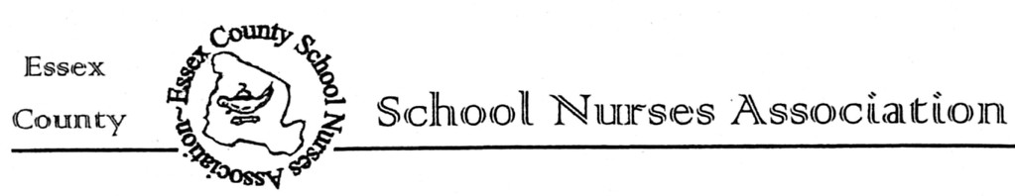
Date: __________________

Re: ECSNA Scholarship for Prospective Nursing Students

Dear Guidance Counselor,

The Essex County School Nurses Association is sponsoring one scholarship, valued at $500.00, for a graduating high school senior, who has been accepted into a four-year pre-nursing or nursing program.

Eligibility Criteria:
- Scholarship applicant must be an Essex County Resident.
- Scholarship applicant must be a graduating high school senior who has been accepted into a 4-year pre-nursing or nursing program. A copy of the college acceptance letter to be included with the application.
- Scholarship applicant shall submit the application (completed in full) and provide a typed Scholarship Essay.

Please copy the attached application and distribute it to all eligible applicants. Please inform all applicants that the application must be received no later than April 15, 2024

Preference for receipt of Application Paperwork: send to cruderman2@gmail.com

The recipient of this scholarship will be notified through their High School Guidance Department by early May 2024. The Scholarship Award, in the amount of $500.00, will be paid to the student’s account at the college they are registered to attend. Information for where to send the Scholarship Award will be obtained at that time, and payment will be submitted in June 2024.

If you should have any questions, please contact me at cruderman2@gmail.com

Sincerely,
Carolyn Ruderman, RN, BSN, CSN-NJ
Acting ECSNA Scholarship Committee Chairperson
Scholarship Application Form

Applicant’s Name: ____________________

Home Address: _______________________________

Home phone Number: __________________

Name of High School: ___________________________

Guidance Counselor/Contact at High School: ___________________

Address of High School: _______________________________

High School phone Number: _________________

Guidance Counselor/Contact at High School EMAIL _______________________

Name of Four-Year Nursing College you have been accepted to: (Acceptance letter must be included): ______________________________________

Eligibility Criteria:
- Scholarship applicant must be an Essex County Resident.
- Scholarship applicant must be a graduating high school senior who has been accepted into a 4-year pre-nursing or nursing program. A copy of the college acceptance letter to be included with the application.
- Scholarship applicants shall submit the application (completed in full) and provide a typed Scholarship Essay.

Scholarship Consideration Requirements:
Please submit a typed personal statement explaining why you should be considered for
the Essex County School Nurses Association Scholarship. In addition, include your need, academic standing, extracurricular participation, leadership, community service, work experience or any other information to support an accurate portrayal of yourself.

Notification And Payment of Awards:
The recipient of the scholarship will be notified through their High School Guidance Department by early May 2024. The Scholarship Award, in the amount of $500.00, will be paid to the student’s account at the college of which they are registered to attend. Information for where to send the Scholarship Award will be obtained at that time, and payment will be submitted in June 2024.

Applications must be received by April 15, 2024, VIA email to: cruderman2@gmail.com

If you should have any questions, please contact me at cruderman2@gmail.com.

Scholarship Application Deadline: April 15, 2024

