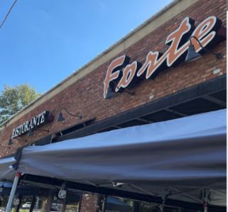
2024
PLEASE JOIN US TO RELAX & ENJOY our MAY DINNER
For
ESSEX COUNTY SCHOOL NURSES ASSOCIATION
*Celebrate* *Door prizes*
DATE: Tuesday, May 14, 2024
PLACE: Forte’s Pizzeria & Ristorante - 182 Bloomfield Ave, Caldwell, NJ 07006
TIME: 4:30pm
COST: $50 for members, non-members and students
ECSNA DINNER RSVP AND ENTRÉE CHOICE FORM for ALL ATTENDEES: CLICK HERE!
Please, all must complete the RSVP google link above regardless of payment type by May 7, 2024. ____________________________________________________________________________
RSVP & Return with payment in the mail, Venmo @Lila-Kurzum or Zelle Lila Kurzum (973-332-7846) by May 7, 2024, as stated above.
Choice of entrée: (meal includes house salad, penne vodka in a bread bowl and choice of beverages – coffee, tea or soda). ECSNA will provide dessert.
______Eggplant Rollatini
______Chicken Francese
______Broiled Salmon (or any style)
Please make checks payable to Essex County School Nurses Association (ECSNA). If you bring cash to the restaurant, please bring the exact amount.

