The Breathe, Move, Focus, Rest Deskside Reset
New Jersey Hope and Healing Frontline Staff
Tammy.Reynolds@rwjbh.org
Mary.Fowler@rwjbh.org
Khalen.Dietz@rwjbh.org
Ann.Funck@rwjbh.org
RWJBH Institute for Prevention and Recovery

Like us—IFPR Hope and Healing
Chair Yoga Routine—10 to 15 minutes
BREATHE
Letting Go Breath—inhale nose, exhale mouth (3 X) forceful exhale if possible.
Belly Breath—Breathe in, imagine you are inflating a white fluffy cloud in your belly that fills your mid chest and upper chest. Exhale. Allow the cloud to slowly deflate from the top of the chest, middle chest, abdomen, pull in Repeat.
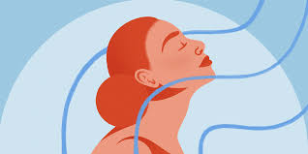
MOVE
Seated Mountain pose
straight spine, roll shoulder blades back and down, arms relaxed at the sides, hanging and palms extending to the floor, pull belly in and slightly up. Engage. Breath and release feeling your mountain get stronger with each inhale and exhale, feeling energy move through your fingers.

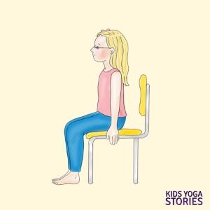
- Arm Sweeps inhale and lift arms palms up overhead. Exhale and lower arms , palms down. 6-7 rounds

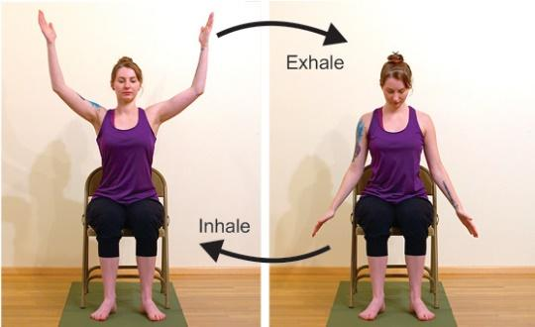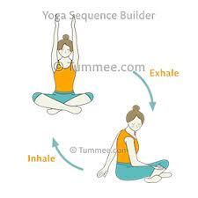

B. Sweep and Twist inhale arms up, move left hand to right knee, twist from waist, right arm to back of chair or side of chair. Twist. Repeat other side. (3 rounds)

Seated Cat Cow Pose breath in raise from hips, extend chest and head and neck upward. Exhale, pull hips and abdomen back and in and curl over. Float this for a few rounds

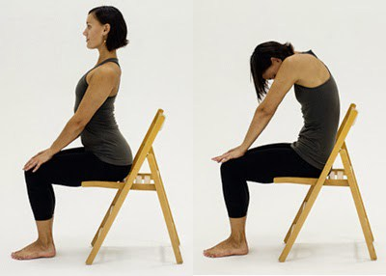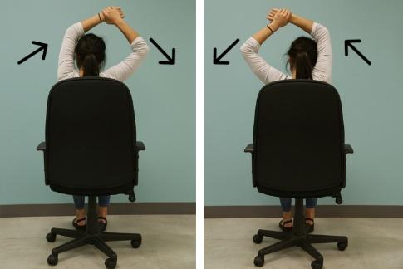Overhead Stretch seated in chair, spine straight, raise left arm overhead, grab wrist with right hand and pull from hip. Release. Repeat on Right side. 3 rounds
Heel Raises feet flat on floor. Raise heels. Feel stretch through the arches, toes flatten, calves stretching. 5 rounds.

Feet Rocking rock feet back and forth up on heels stretch front of ankles, down on balls of feet and lift heels stretching and flattening the toes, repeat 5 rounds (stretch toes and place down one at a time)
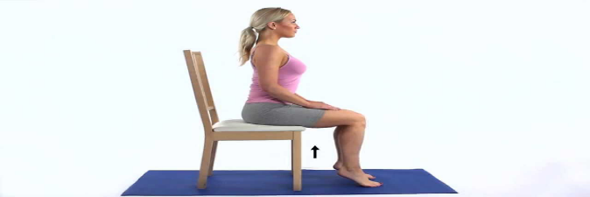
FOCUS
I am so strong. Touch thumb and each finger as slowly say I (index) Am (middle) So (ring) Strong (pinky) Repeat, Speed, then slow.

RELAX—CONSTRUCTIVE REST
Seated relaxation elbows on knees or desk. Rest chin into the heels of your hand's palms cup the face. Breathe in and out.

(Legs up the Wall) if available—on the floor, butt touching base of wall or as close as possible, raise legs and allow the weight of the legs to let go, allow the weight of the body to sink into the floor.
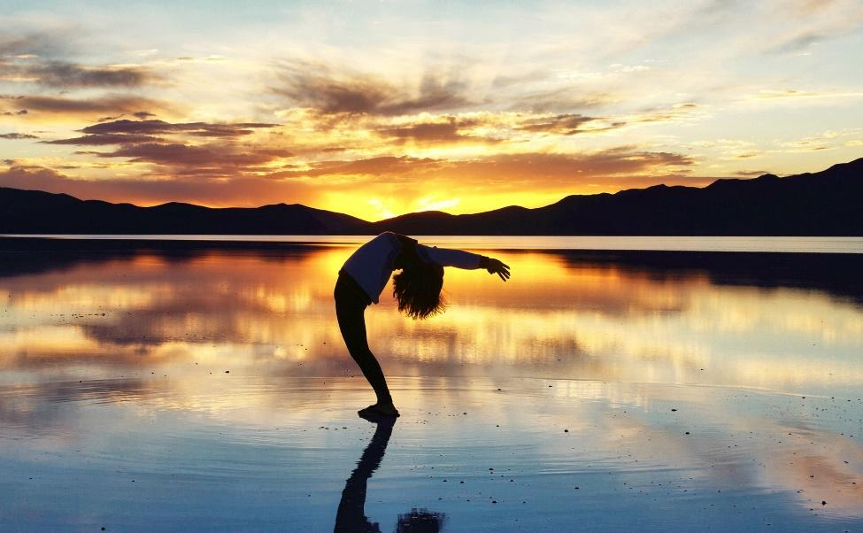
Affirmation: “In the center of life’s storms, I stand serene.”

